TASK 1.1 : JAVA LAMBDA EXPRESSION
PROGRAM:
import java.io.*;
import java.util.*;
interface PerformOperation {
boolean check(int a);
}
class MyMath {
public static boolean checker(PerformOperation p, int num) {
return p.check(num);
}

public static PerformOperation isOdd() {
return n -> n % 2 != 0;
}
public static PerformOperation isPrime() {
return n -> {
if (n < 2) return false;

for (int i = 2; i < n; i++) {
if (n % i == 0) return false;
}
return true;
};
}
public static PerformOperation isPalindrome() {
return n -> {
int original = n;
int reverse = 0
while (n > 0) {
reverse = reverse * 10 + n % 10;
n = n / 10;
}
return original == reverse;
};
}
}
OUTPUT:
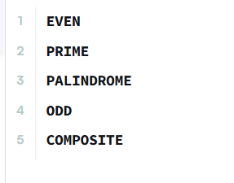

TASK 1.2:SALARY TRANSFORMATION SYSTEM
PROGRAM:
import java.util.*;
import java.util.stream.*;

public class Main {
public static void main(String[] args) {
Scanner sc = new Scanner(System.in);
int n = sc.nextInt();
List<Integer> salaries = new ArrayList<>();
for (int i = 0; i < n; i++) {
salaries.add(sc.nextInt());
}
salaries.stream()
.map(salary -> salary + (salary * 10 / 100))
.forEach(salary -> System.out.print(salary + " "));
}
}
OUTPUT:
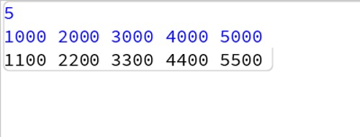

TASK 1.3:JAVA SORT
PROGRAM:
import java.util.*;
class Student{
private int id;
private String fname;
private double cgpa;
public Student(int id, String fname, double cgpa) {
super();
this.id = id;
this.fname = fname;
this.cgpa = cgpa;
}
public int getId() {
return id;
}
public String getFname() {
return fname;
}
public double getCgpa() {
return cgpa;
}
}
public class Solution
{
public static void main(String[] args){
Scanner in = new Scanner(System.in);
int testCases = Integer.parseInt(in.nextLine());
List<Student> studentList = new ArrayList<Student>();
while(testCases>0){
int id = in.nextInt();
String fname = in.next();
double cgpa = in.nextDouble();
Student st = new Student(id, fname, cgpa);
studentList.add(st);
testCases--;
}
Collections.sort(studentList, new Comparator<Student>() {
@Override
public int compare(Student s1, Student s2) {

if (Double.compare(s2.getCgpa(), s1.getCgpa()) != 0) {
return Double.compare(s2.getCgpa(), s1.getCgpa());
}
// If CGPA is same, compare by First Name (Ascending)
else if (!s1.getFname().equals(s2.getFname())) {
return s1.getFname().compareTo(s2.getFname());
}
// If CGPA and First Name are same, compare by ID (Ascending)
else {
return Integer.compare(s1.getId(), s2.getId());
}
}
});
for(Student st: studentList){
System.out.println(st.getFname());
}
}
}

OUTPUT:
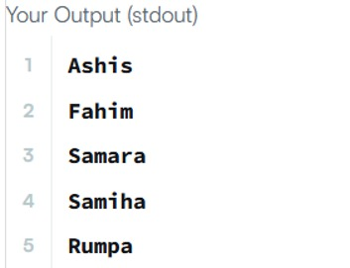

TASK 1.4:SORT ARRAY BY PARITY
PROGRAM:
class Solution {
public int[] sortArrayByParity(int[] nums) {
return java.util.stream.IntStream.concat(
Arrays.stream(nums).filter(n -> n % 2 == 0),
Arrays.stream(nums).filter(n -> n % 2 != 0)
).toArray();

}
}
OUTPUT:
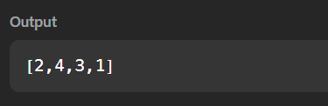

TASK 1.5:SORTING COMPARATOR
PROGRAM:
import java.util.*;
class Player {
String name;
int score;
Player(String name, int score) {
this.name = name;
this.score = score;
}
}
class Checker implements Comparator<Player>
public int compare(Player a, Player b) {
return Comparator
.comparingInt((Player p) -> p.score)
.reversed()
.thenComparing(p -> p.name)
.compare(a, b)
}
}
OUTPUT:
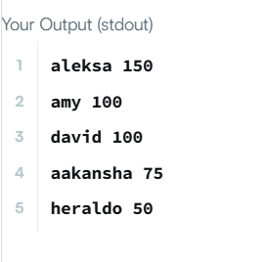

TASK 1.6:JAVA COMPARATOR
PROGRAM:
import java.util.*;
class Checker implements Comparator<Player> {
public int compare(Player a, Player b){
return Comparator
.comparingInt((Player p)-> p.score)
.reversed()
.thenComparing(p -> p.name)
.compare(a,b);
}
}
OUTPUT:
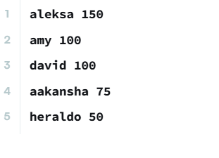

TASK 1.7:RICHEST CUSTOMER WEALTH
PROGRAM:
import java.util.Arrays;
class Solution {
public int maximumWealth(int[][] accounts) {
return Arrays.stream(accounts)
.mapToInt(customer -> Arrays.stream(customer).sum())
.max()
.getAsInt();
}
}
OUTPUT:
